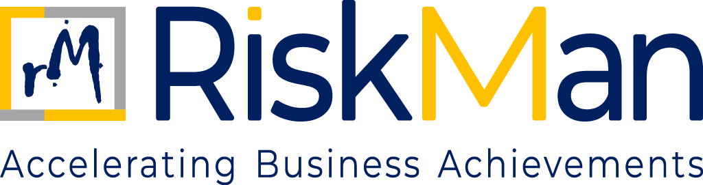
Code of Ethics
TABLE OF CONTENTS
Code of Ethics

- Objective………………………………………………………………………………………………………………………….…….3
- Scope……..………………….…………………………………………………………………………………………………………..3
- Ethics Governance and Tone from the Top………………………………………………………………………………3
- Core Ethics Principles………………………………………………………………………………………………………………3
- Compliance with Law and Standard………………………………………………………………………………………..4
- Conflict of Interest………………………………………………………………………………………………………………….4
- Fair Business Practice……………………………………………………………………………………………………………..4
- Respectful and Inclusive Workplace………………………………………………………………………………………..4
- Use of Firm Resource and Information……………………………………………………………………………………5
- Reporting Ethical Concern………………………………………………………………………………………………………5
- Breach and Consequences……………………………………………………………………………………………………..5
- Training and Awareness………………………………………………………………………………………………………….5

CODE OF ETHICS
- OBJECTIVE

The objective of this Code of Ethics (“Code”) is to define the ethical principles, values, and standards of conduct that guide all professional and business activities of RiskMan Consulting LLP (“RiskMan” or “the Firm”). This Code aims to:

- Establish a common ethical framework for decision-making and behaviour.
- Promote integrity, independence, and professional excellence.
- Protect the interests of clients, employees, regulators, and other stakeholders; and
- Reinforce trust in the Firm’s judgment, advice, and conduct.
This Code represents the ethical foundation upon which all other Firm policies are built.
- SCOPE

This policy applies to all individuals and entities associated with RiskMan Consulting LLP. It covers all employees, including those who are permanent, contractual, or interns, as well as partners, consultants, and associates who are professionally engaged with the Firm. Additionally, the policy extends to clients, suppliers, vendors, and any other third-party stakeholders who interact with or are connected to the operations and business activities of RiskMan in any capacity.

- ETHICAL GOVERNANCE AND TONE FROM THE TOP

RiskMan’s Partners are responsible for setting the “Tone from the top” by:
- Demonstrating ethical leadership
- Acting consistently with the principles set out in this Code
- Holding themselves and others accountable for ethical conduct
Ethical considerations shall be integral to strategic, operational, and client-related decisions.
- CORE ETHICAL PRINCIPLES

RiskMan and its personnel shall adhere to the following core ethical principles:
4.1 Integrity: Act honestly, fairly, and transparently in all professional and business dealings. Misrepresentation, deception, or unethical conduct is strictly prohibited.
4.2 Objectivity and Independence: Exercise professional judgment free from bias, conflict of interest, or undue influence. Independence in fact and appearance shall be maintained at all times.

4.3 Professional Competence and Due Care: Maintain appropriate professional knowledge and skill, perform duties diligently, and apply sound judgment in accordance with applicable standards.
4.4 Confidentiality: Protect confidential and proprietary information and use it only for legitimate business purposes.
4.5 Accountability: Take responsibility for decisions and actions and be prepared to explain and justify them when required.
- COMPLIANCE WITH LAWS AND STANDARDS

All personnel shall comply with:
- Applicable laws and regulations,
- Professional standards and codes of conduct,
- Contractual obligations,
- The Firm’s internal policies and procedures
Ignorance of legal or policy requirements is not an acceptable defence.
- CONFLICTS OF INTEREST
Personnel shall avoid situations where personal, financial, or other interests conflict, or appear to conflict, with the interests of the firm or its clients.
All conflicts shall be disclosed and managed in accordance with the Conflict-of-Interest Policy. Unmanaged conflicts are strictly prohibited.
- FAIR BUSINESS PRACTICES
RiskMan is committed to fair and ethical business practices. Personnel shall:
- Compete fairly and honestly
- Avoid bribery, corruption, or improper inducements
- Comply with the Firm’s Anti-Bribery and Anti-Corruption Policy; and
- Not engage in conduct that could damage the Firm’s reputation.
- RESPECTFUL AND INCLUSIVE WORKPLACE

RiskMan is committed to maintaining a workplace that is respectful, inclusive, and free from discrimination, harassment, or retaliation.

All personnel are expected to treat others with dignity and professionalism and comply with the Firm’s people-related policies.

- USE OF FIRM RESOURCES AND INFORMATION

Firm resources, systems, and information shall be:
- Used responsibly and for legitimate business purposes only; and
- Protected against misuse, loss, or unauthorised access.
- REPORTING ETHICAL CONCERNS

Personnel are encouraged and expected to report:
- Suspected ethical violations
- Unlawful or improper conduct
- Breaches of this Code or other Firm policies
Reports may be made through designated channels in accordance with the Firm’s Whistleblower Policy.
- BREACHES AND CONSEQUENCES

Breaches of this Code may result in:
- Disciplinary action
- Termination of employment or engagement
- Legal or regulatory action, where applicable.
Consequences shall be proportionate to the severity of the violation.
- TRAINING AND AWARENESS

The Firm promotes ethical awareness through Induction programmes, Periodic communication, and Training initiatives, as appropriate. All personnel are expected to understand and uphold this Code.

